Ryan Clifton (Student)

Ryan Clifton Paint calculator

Table of Contents

Introduction: 1

Assumptions: 1

Improvements: 1

# Introduction:

I have created a program using C# programming language with a windows form and it is used to work out the area of a floor, volume of a room and the amount of paint needed to paint the walls of the room. The requirements can be found using the link below:

<https://borwell.com/software-challenge/>

# Assumptions:

I made assumptions that are wanting to find dimensions of a room that is either a square or a rectangle and that the rooms have no windows or doors.

# Improvements:

If I had more time and more knowledge, I would have added the functionality to have a room with more than four walls and be able to work out the area, volume and amount of paint needed to paint a room with doors and windows in them.

# Windows form:

Below is an image of what the application looks like when the program is run.

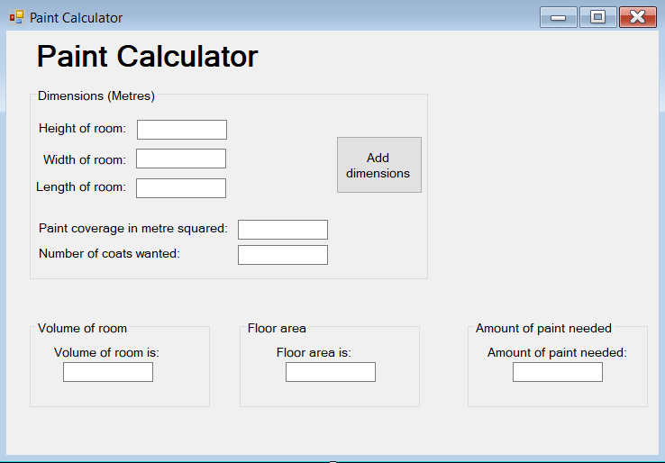

TxtPaint

txtFloor

txtVolume

txtCoats

txtCoverage

txtLength

txtWidth

txtHeight

# About the program:

I made the program using C# with a windows form, so it is more user friendly than a console app. The framework that the program is using is .Netframework4.6.1. when programming the program, I used camelCase for the variables used in the code and I used Hungarian notation to name the objects on the form.